**Question 1:**

**CODE**

#include<stdio.h>

#include<conio.h>

void main (void){

int number,d1,temporary,newnumber;

printf("Enter a '5' five digit number to check its divisibility by 7\n");

scanf("%d",&number);

d1=number%10;

temporary=number/10;

newnumber=temporary-2*d1;

d1=newnumber%10;

newnumber=newnumber/10;

newnumber=newnumber-2*d1;

d1=newnumber%10;

newnumber=newnumber/10;

newnumber=newnumber-2*d1;

if ((newnumber==-7)||(newnumber==0)||(newnumber==7)){

printf("The number is divisible by 7\n");

}

else

printf("The number is not divisible by 7\n");

}

**OUTPUT**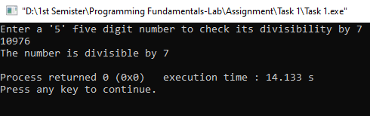

**Question 2:**

**CODE**

#include<stdio.h>

#include<conio.h>

void main (void){

float noofcalories,fatgrams,caloriesfromfat,totalcalories,percentofcalories;

printf("Enter the number of calories and fat grams in food\n");

scanf("%f %f",&noofcalories,&fatgrams);

//If the calories from fat are less than 30% of the total calories of the food, the food is low in fat

caloriesfromfat=fatgrams*9;

totalcalories=noofcalories+caloriesfromfat;

percentofcalories=caloriesfromfat/totalcalories*100;

if((noofcalories<0)||(fatgrams<0)||(caloriesfromfat>totalcalories)){

printf("\nEither the calories or fat grams were incorrectly entered\n");

}else if (caloriesfromfat>0.3*totalcalories){

printf("\nPercentage of calories that come from fat is %.2f\n",percentofcalories);

} else if (caloriesfromfat<0.3*totalcalories){

printf("\nPercentage of calories that come from fat is %.2f\n",percentofcalories);

printf("\nThe food is low in fats\n");

}

}

**OUTPUT**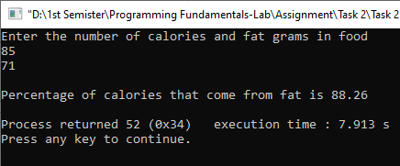

**Question 3:**

**CODE**

#include<stdio.h>

#include<conio.h>

void main (void){

float NTS,FSC;

printf("Enter your FSC marks: \n");

scanf("%f", &FSC);

printf("Enter your NTS marks: \n");

scanf("%f", &NTS);

if ((FSC>70)&&(NTS>=70)){

printf("\nOxford University\n");

printf("\nIT\n");

}else if ((FSC>70)&&(NTS>=60)){

printf("\nOxford University\n");

printf("\nElectronics\n");

}else if ((FSC>70)&&(NTS>=50)){

printf("\nOxford University\n");

printf("\nTelecommunication\n");

}else if((FSC>=60 && FSC<=70)&&(NTS>=50)){

printf("\nMIT\n");

printf("\nIT\n");

}else if((FSC>=50 && FSC<=59)&&(NTS>=50)){

printf("\nMIT\n");

printf("\nChemical\n");

}else if((FSC<50 && FSC>40)&&(NTS>=50)){

printf("\nMIT\n");

printf("\nComputer\n");

}

}

**OUTPUT**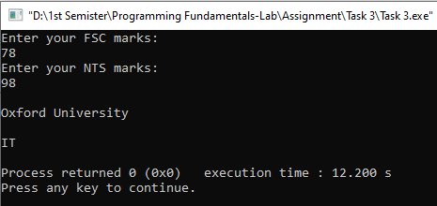

**Question 4:**

**CODE**

#include<stdio.h>

#include<conio.h>

void main (void){

int weekday,vacation;

weekday=vacation=0;

printf("Please follow the following instruction\n");

printf("\n1 If its a weekday\n0 If its not a weekday\n");

scanf("%d",&weekday);

printf("\nPlease follow the following instruction\n");

printf("\n1 If its a vacation\n0 If its not a vacation\n");

scanf("%d",&vacation);

if (weekday==0 && vacation==0)

printf("\nTrue....You can sleepin\n");

else if (weekday==1 && vacation==0)

printf("\nFalse....You cannot sleepin\n");

else if (weekday==0 && vacation==1)

printf("\nTrue....You can sleepin\n");

else

printf("\nInvalid Input\n");

}

**OUTPUT**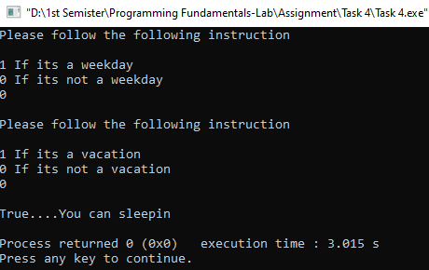

**Question 5:**

**CODE**

#include<stdio.h>

#include<conio.h>

void main (void){

char coffee,size;

int Totaltime;

printf("Enter your choice for coffee\nB= Black \nW=White\n");

coffee=getche();

printf("\nEnter size of coffee you want\nD= Double \nM= Manual\n");

size=getche();

switch(coffee){

case 'W':

if((coffee=='W') && (size=='M')){

printf("\n______________________________________\n");

printf("Operation White Coffee\n");

printf("______________________________________\n");

printf("Put Water 15 mins\n");

printf("Sugar 15 mins\n");

printf("Mix Well 20 mins\n");

printf("Add Coffee 2 mins\n");

printf("Add Milk 4 mins\n");

printf("Mix Well 20 mins\n");

printf("\n______________________________________");

Totaltime= 15+15+20+2+4+20;

printf("\nThe Total Bake Time is %d minutes",Totaltime);}

else{

printf("\n______________________________________\n");

printf("Operation White Coffee\n");

printf("______________________________________\n");

printf("Put Water 23 mins\n");

printf("Sugar 23 mins\n");

printf("Mix Well 30 mins\n");

printf("Add Coffee 3 mins\n");

printf("Add Milk 6 mins\n");

printf("Mix Well 30 mins\n");

printf("\n______________________________________");

Totaltime= 23+23+30+3+6+30;

printf("\nThe Total Bake Time is %d minutes",Totaltime);

}

break;

case 'B':

if ((coffee=='B')&&(size=='M')){

printf("\n______________________________________\n");

printf("Operation Black Coffee\n");

printf("______________________________________\n");

printf("Put Water 20 mins\n");

printf("Sugar 20 mins\n");

printf("Mix Well 25 mins\n");

printf("Add Coffee 15 mins\n");

printf("Add Milk - mins\n");

printf("Mix Well 25 mins\n");

printf("\n______________________________________");

Totaltime= 20+20+25+15+0+25;

printf("\nThe Total Bake Time is %d minutes",Totaltime);}

else{

printf("\n______________________________________\n");

printf("Operation Black Coffee\n");

printf("______________________________________\n");

printf("Put Water 30 mins\n");

printf("Sugar 30 mins\n");

printf("Mix Well 38 mins\n");

printf("Add Coffee 23 mins\n");

printf("Add Milk - mins\n");

printf("Mix Well 38 mins\n");

printf("\n______________________________________");

Totaltime= 30+30+38+23+0+38;

printf("\nThe Total Bake Time is %d minutes",Totaltime);

}

}

}

**OUTPUT**

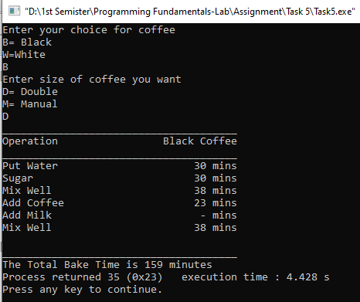

**Question 6:**

**CODE**

#include<stdio.h>

#include<conio.h>

void main (void){

char choice,types,order;

int quantity,type,totalcost,p1,p2,p3,p4;

quantity=totalcost=p1=p2=p3=p4=0;

//Burger= Rs.200; French Fries= Rs.50; Pizza= Rs.500; Sandwhiches= Rs.150

printf("The following is our menu\n");

printf("B=Burger cost Rs. 200\n");

printf("F=French Fries cost Rs. 50\n");

printf("P=Pizza cost Rs. 500\n");

printf("S=Sandwhiches cost Rs. 150\n");

printf("\nHow many types of snacks you want to order?\n\n1, 2, 3 or 4?\n");

types=getche();

if(types == '1'){

printf("\nPlease enter the snack you have to order=\n");

type = getche();

printf("\nEnter the quantity of the selected snack=\n");

switch(type){

case 'B':

scanf("%d", &p1);

break;

case 'F':

scanf("%d", &p2);

break;

case 'P':

scanf("%d", &p3);

break;

case 'S':

scanf("%d", &p4);

break;

default:

printf("\nInvalid input\n");

}

} else if(types == '2'){

printf("Please enter the first snack you have to order=\n");

type = getche();

printf("\nEnter the quantity of the selected snack=\n");

switch(type){

case 'B':

scanf("%d", &p1);

break;

case 'F':

scanf("%d", &p2);

break;

case 'P':

scanf("%d", &p3);

break;

case 'S':

scanf("%d", &p4);

break;

default:

printf("\nInvalid input\n");

}

printf("Please enter the second snack you have to order=\n");

type = getche();

printf("\nEnter the quantity of the selected snack=\n");

switch(type){

case 'B':

scanf("%d", &p1);

break;

case 'F':

scanf("%d", &p2);

break;

case 'P':

scanf("%d", &p3);

break;

case 'S':

scanf("%d", &p4);

break;

default:

printf("\nInvalid input\n");

}

} else if(types == '3'){

printf("\nPlease enter the first snack you have to order=\n");

type = getche();

printf("\nEnter the quantity of the selected snack=\n");

switch(type){

case 'B':

scanf("%d", &p1);

break;

case 'F':

scanf("%d", &p2);

break;

case 'P':

scanf("%d", &p3);

break;

case 'S':

scanf("%d", &p4);

break;

default:

printf("\nInvalid input\n");

}

printf("Please enter the second snack you have to order=\n");

type = getche();

printf("\nEnter the quantity of the selected snack=\n");

switch(type){

case 'B':

scanf("%d", &p1);

break;

case 'F':

scanf("%d", &p2);

break;

case 'P':

scanf("%d", &p3);

break;

case 'S':

scanf("%d", &p4);

break;

default:

printf("\nInvalid input\n");

}

printf("Please enter the third snack you have to order=\n");

type = getche();

printf("\nEnter the quantity of the selected snack=\n");

switch(type){

case 'B':

scanf("%d", &p1);

break;

case 'F':

scanf("%d", &p2);

break;

case 'P':

scanf("%d", &p3);

break;

case 'S':

scanf("%d", &p4);

break;

default:

printf("\nInvalid input\n");

}

} else if(types == '4'){

printf("Please enter the first snack you want to order=\n");

type = getche();

printf("\nEnter the quantity of the selected snack=\n");

switch(type){

case 'B':

scanf("%d", &p1);

break;

case 'F':

scanf("%d", &p2);

break;

case 'P':

scanf("%d", &p3);

break;

case 'S':

scanf("%d", &p4);

break;

default:

printf("Invalid input\n");

}

printf("Please enter the second snack you want to order=\n");

type = getche();

printf("\nEnter the quantity of the selected snack=\n");

switch(type){

case 'B':

scanf("%d", &p1);

break;

case 'F':

scanf("%d", &p2);

break;

case 'P':

scanf("%d", &p3);

break;

case 'S':

scanf("%d", &p4);

break;

default:

printf("\nInvalid input\n");

}

printf("Please enter the third snack you want to order=\n");

type = getche();

printf("\nEnter the quantity of the selected snack=\n");

switch(type){

case 'B':

scanf("%d", &p1);

break;

case 'F':

scanf("%d", &p2);

break;

case 'P':

scanf("%d", &p3);

break;

case 'S':

scanf("%d", &p4);

break;

default:

printf("\nInvalid input\n");

}

printf("Please enter the fourth snack you want to order=\n");

type = getche();

printf("\nEnter the quantity of the selected snack=\n");

switch(type){

case 'B':

scanf("%d", &p1);

break;

case 'F':

scanf("%d", &p2);

break;

case 'P':

scanf("%d", &p3);

break;

case 'S':

scanf("%d", &p4);

break;

default:

printf("\nInvalid input\n");

}

}

printf("\tYour order\n");

//Burger= Rs.200; French Fries= Rs.50; Pizza= Rs.500; Sandwhiches= Rs.150;

if(p1 != 0){

printf("%d Burger of Rs %d\n", p1, p1*200);

}

if(p2 != 0){

printf("%d French Fries of Rs %d\n", p2, p2*50);

}

if(p3 != 0){

printf("%d Pizza of Rs. %d\n", p3, p3*500);

}

if(p4 != 0){

printf("\n%d Sandwiches of Rs. %d\n", p4, p4*150);

}

totalcost=200*p1+50*p2+500*p3+150*p4;

printf("\n\tTotal Cost is %d",totalcost);

printf("\nThanks for your order!\nVisit us again soon...\n");

}

**OUTPUT**